**A SIMPLE CALCULATOR USING**

**KOTLIN IN ANDRIOD**

**SUBMITTED BY:**

**RAJU YERIPILLI-20GK1A0424**

**DEPARTMENT OF ELECTRONICS AND COMMUNICATION ENGINEERING**

**PRIYADARSHINI INSTITUTE OF TECHNOLOGY & MANAGEMENT**

**5th Mile,Pulladigunta,Vatticherukuru,Guntur-522017**

**1.INTRODUCTION**

Since we’ll be building a Calculator app, let’s Pick a Scope that’s not too complicated foe learning but also not too basic for covering different aspects of creating an app.

The features we’ll implement include:

* Add, subtract, multiply, divide
* Support decimal values
* Calculate percentages
* Invert values
* Reset functionality
* Format larger numbers
* Output resize based on length

Let’s start with implementation,

**2.APPENDIX**

**Step 1**

Create a new project and select an empty activity.

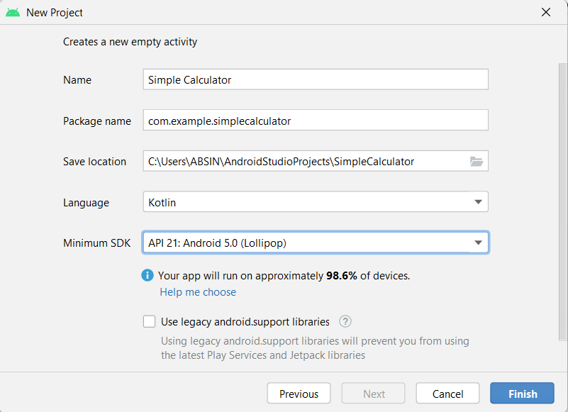

Select kotlin language and click on the finish button.

**Step 2**

Go to activity_main.xml and add the following code.

**Activity_main xml**

<?xml version="1.0" encoding="utf-8"?>

<RelativeLayout

xmlns:android="<http://schemas.android.com/apk/res/android>"

xmlns:app="<http://schemas.android.com/apk/res-auto>"

xmlns:tools="<http://schemas.android.com/tools>"

android:layout_width="match_parent"

android:layout_height="match_parent"

tools:context=".MainActivity">

<LinearLayout

android:layout_width="match_parent"

android:layout_height="280dp"

android:orientation="vertical">

<com.google.android.[material](https://webplatform.github.io/docs/mathml/elements/material).[card](https://webplatform.github.io/docs/mathml/elements/card).[MaterialCardView](https://webplatform.github.io/docs/mathml/elements/MaterialCardView)

android:layout_width="match_parent"

android:layout_height="wrap_content"

android:layout_margin="15dp"

android:elevation="20dp"

app:strokeColor="@color/teal_700"

app:strokeWidth="1dp">

<[com](https://webplatform.github.io/docs/mathml/elements/com).[google](https://webplatform.github.io/docs/mathml/elements/google).[android](https://webplatform.github.io/docs/mathml/elements/android).[material](https://webplatform.github.io/docs/mathml/elements/material).[textfield](https://webplatform.github.io/docs/mathml/elements/textfield).[TextInputEditText](https://webplatform.github.io/docs/mathml/elements/TextInputEditText)

android:id="@+id/input1"

android:inputType="number"

[style](https://webplatform.github.io/docs/mathml/attributes/style)="@style/Widget.MaterialComponents.TextInputLayout.OutlinedBox.Dense"

android:layout_width="match_parent"

android:layout_height="wrap_content"

android:hint="Enter 1st Number"

android:textSize="20dp" />

</[com](https://webplatform.github.io/docs/mathml/elements/com).[google](https://webplatform.github.io/docs/mathml/elements/google).[android](https://webplatform.github.io/docs/mathml/elements/android).[material](https://webplatform.github.io/docs/mathml/elements/material).[card](https://webplatform.github.io/docs/mathml/elements/card).[MaterialCardView](https://webplatform.github.io/docs/mathml/elements/MaterialCardView)>

<[com](https://webplatform.github.io/docs/mathml/elements/com).[google](https://webplatform.github.io/docs/mathml/elements/google).[android](https://webplatform.github.io/docs/mathml/elements/android).[material](https://webplatform.github.io/docs/mathml/elements/material).[card](https://webplatform.github.io/docs/mathml/elements/card).[MaterialCardView](https://webplatform.github.io/docs/mathml/elements/MaterialCardView)

android:layout_width="match_parent"

android:layout_height="wrap_content"

android:layout_marginLeft="15dp"

android:layout_marginRight="15dp"

android:elevation="20dp"

app:strokeColor="@color/teal_700"

app:strokeWidth="1dp">

<[com](https://webplatform.github.io/docs/mathml/elements/com).[google](https://webplatform.github.io/docs/mathml/elements/google).[android](https://webplatform.github.io/docs/mathml/elements/android).[material](https://webplatform.github.io/docs/mathml/elements/material).[textfield](https://webplatform.github.io/docs/mathml/elements/textfield).[TextInputEditText](https://webplatform.github.io/docs/mathml/elements/TextInputEditText)

android:id="@+id/input2"

android:inputType="number"

[style](https://webplatform.github.io/docs/mathml/attributes/style)="@style/Widget.MaterialComponents.TextInputLayout.OutlinedBox.Dense"

android:layout_width="match_parent"

android:layout_height="wrap_content"

android:hint="Enter 2nd Number"

android:textSize="20dp" />

</[com](https://webplatform.github.io/docs/mathml/elements/com).[google](https://webplatform.github.io/docs/mathml/elements/google).[android](https://webplatform.github.io/docs/mathml/elements/android).[material](https://webplatform.github.io/docs/mathml/elements/material).[card](https://webplatform.github.io/docs/mathml/elements/card).[MaterialCardView](https://webplatform.github.io/docs/mathml/elements/MaterialCardView)>

<[com](https://webplatform.github.io/docs/mathml/elements/com).[google](https://webplatform.github.io/docs/mathml/elements/google).[android](https://webplatform.github.io/docs/mathml/elements/android).[material](https://webplatform.github.io/docs/mathml/elements/material).[card](https://webplatform.github.io/docs/mathml/elements/card).[MaterialCardView](https://webplatform.github.io/docs/mathml/elements/MaterialCardView)

android:layout_width="match_parent"

android:layout_height="wrap_content"

android:layout_marginLeft="15dp"

android:layout_marginTop="12dp"

android:layout_marginRight="15dp"

android:elevation="20dp"

app:strokeColor="@color/teal_700"

app:strokeWidth="1dp">

<[TextView](https://webplatform.github.io/docs/mathml/elements/TextView)

android:id="@+id/result"

android:layout_width="match_parent"

android:layout_height="40dp"

android:gravity="center"

android:text="Result"

android:textSize="20sp"/>

</[com](https://webplatform.github.io/docs/mathml/elements/com).[google](https://webplatform.github.io/docs/mathml/elements/google).[android](https://webplatform.github.io/docs/mathml/elements/android).[material](https://webplatform.github.io/docs/mathml/elements/material).[card](https://webplatform.github.io/docs/mathml/elements/card).[MaterialCardView](https://webplatform.github.io/docs/mathml/elements/MaterialCardView)>

<[LinearLayout](https://webplatform.github.io/docs/mathml/elements/LinearLayout)

android:layout_width="match_parent"

android:layout_height="wrap_content"

android:orientation="horizontal">

<[com](https://webplatform.github.io/docs/mathml/elements/com).[google](https://webplatform.github.io/docs/mathml/elements/google).[android](https://webplatform.github.io/docs/mathml/elements/android).[material](https://webplatform.github.io/docs/mathml/elements/material).[button](https://webplatform.github.io/docs/html/elements/button).[MaterialButton](https://webplatform.github.io/docs/html/elements/MaterialButton)

android:id="@+id/plus"

android:layout_width="wrap_content"

android:layout_height="wrap_content"

android:layout_marginLeft="15dp"

android:layout_marginTop="15dp"

android:backgroundTint="@color/teal_700"

android:text="+"

android:textSize="20dp"

app:strokeColor="@color/white"

app:strokeWidth="2dp" />

<[com](https://webplatform.github.io/docs/html/elements/com).[google](https://webplatform.github.io/docs/html/elements/google).[android](https://webplatform.github.io/docs/html/elements/android).[material](https://webplatform.github.io/docs/mathml/elements/material).[button](https://webplatform.github.io/docs/html/elements/button).[MaterialButton](https://webplatform.github.io/docs/html/elements/MaterialButton)

android:id="@+id/minus"

android:layout_width="wrap_content"

android:layout_height="wrap_content"

android:layout_marginLeft="5dp"

android:layout_marginTop="15dp"

android:backgroundTint="@color/teal_700"

android:text="-"

android:textSize="20dp"

app:strokeColor="@color/white"

app:strokeWidth="2dp" />

<[com](https://webplatform.github.io/docs/html/elements/com).[google](https://webplatform.github.io/docs/html/elements/google).[android](https://webplatform.github.io/docs/html/elements/android).[material](https://webplatform.github.io/docs/mathml/elements/material).[button](https://webplatform.github.io/docs/html/elements/button).[MaterialButton](https://webplatform.github.io/docs/html/elements/MaterialButton)

android:id="@+id/multiply"

android:layout_width="wrap_content"

android:layout_height="wrap_content"

android:layout_marginLeft="5dp"

android:layout_marginTop="15dp"

android:backgroundTint="@color/teal_700"

android:text="*"

android:textSize="20dp"

app:strokeColor="@color/white"

app:strokeWidth="2dp" />

<[com](https://webplatform.github.io/docs/html/elements/com).[google](https://webplatform.github.io/docs/html/elements/google).[android](https://webplatform.github.io/docs/html/elements/android).[material](https://webplatform.github.io/docs/mathml/elements/material).[button](https://webplatform.github.io/docs/html/elements/button).[MaterialButton](https://webplatform.github.io/docs/html/elements/MaterialButton)

android:id="@+id/divide"

android:layout_width="wrap_content"

android:layout_height="wrap_content"

android:layout_marginLeft="5dp"

android:layout_marginTop="15dp"

android:layout_marginRight="15dp"

android:backgroundTint="@color/teal_700"

android:text="/"

android:textSize="20dp"

app:strokeColor="@color/white"

app:strokeWidth="2dp" />

</[LinearLayout](https://webplatform.github.io/docs/html/elements/LinearLayout)>

</[LinearLayout](https://webplatform.github.io/docs/html/elements/LinearLayout)>

</[RelativeLayout](https://webplatform.github.io/docs/html/elements/RelativeLayout)>

**Explanation**

Here, I am taking a relative layout and inside this layout, we have a linear layout having an orientation vertical. I am Taking two text Input Edit Text and one Text inside this linear layout. I have used Material Card View to design the Text Input Edit Text and Text View. Now I am taking another linear layout having an orientation horizontal, We have to take four material buttons for performing addition, subtraction, multiplication, and division operations inside this inner linear layout.

**activity_mail.xml layout**

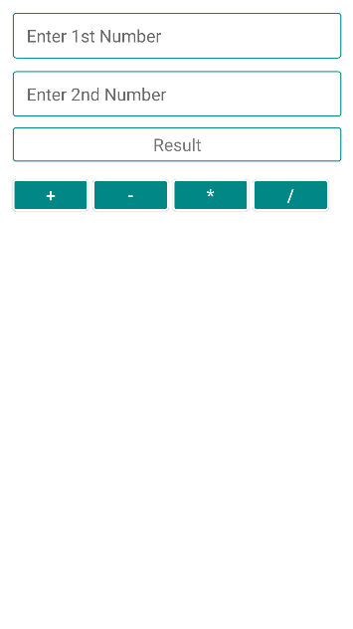

**Step 3**

Go to mainActivity.kt and add the following code

**MainActivity.kt**

package com.example.simplecalculator

import android.graphics.Color

import android.graphics.drawable.ColorDrawable

import androidx.appcompat.app.AppCompatActivity

import android.os.Bundle

import kotlinx.android.synthetic.main.activity_main.*

import java.math.BigDecimal

import java.math.RoundingMode

class MainActivity : AppCompatActivity() {

override fun onCreate(savedInstanceState: Bundle?) {

super.onCreate(savedInstanceState)

setContentView(R.layout.activity_main)

supportActionBar?.setBackgroundDrawable(

ColorDrawable(Color.parseColor("#FF018786")))

plus.setOnClickListener {

add()

}

minus.setOnClickListener {

subtract()

}

multiply.setOnClickListener {

multiply()

}

divide.setOnClickListener {

divide()

}

}

fun inputIsNotEmpty():Boolean{

var b=true;

if(input1.text.toString().trim().isEmpty()){

input1.error="Required"

input1.requestFocus()

b=false;

}

if(input2.text.toString().trim().isEmpty()){

input2.error="Required"

input2.requestFocus()

b=false;

}

return b;

}

fun add(){

if(inputIsNotEmpty()){

var inputdata1=input1.text.toString().trim().toBigDecimal()

var inputdata2=input2.text.toString().trim().toBigDecimal()

result.text=inputdata1.add(inputdata2).toString()

}

}

fun subtract(){

if(inputIsNotEmpty()){

var inputdata1=input1.text.toString().trim().toBigDecimal()

var inputdata2=input2.text.toString().trim().toBigDecimal()

result.text=inputdata1.subtract(inputdata2).toString();

}

}

fun multiply(){

if(inputIsNotEmpty()){

var inputdata1=input1.text.toString().trim().toBigDecimal()

var inputdata2=input2.text.toString().trim().toBigDecimal()

result.text=inputdata1.multiply(inputdata2).toString()

}

}

fun divide(){

if(inputIsNotEmpty()){

var inputdata1=input1.text.toString().trim().toBigDecimal()

var inputdata2=input2.text.toString().trim().toBigDecimal()

if(inputdata2.compareTo(BigDecimal.ZERO)==0){

input2.error="invalid input"

}else {

result.text = inputdata1.divide(inputdata2, 2, RoundingMode.HALF_UP).toString();

}

}

}

}

**Explanation**

First, we have used supportActionBar to change the background color of ActionBar. Now we applied setOnClickListener to all the buttons which are defined in the activity_main.xml. When the user clicks on any button, the inputIsNotEmpty() function will be called and this method will check whether the input field is empty or not. If any input field is empty then it will return a false value otherwise it will return a true value. If the inputIsNotEmpty() function returns a true value then statements that are written inside if() condition of a particular method will be executed. For example, if we click on the plus button then add() method will be called, and inside add() method first it will check inputIsNotEmpty() method to return a true or false value. If a value is true then the addition of input numbers will be displayed on textview.

**Step 3**

Now click on the run button and launch the application

**Output**



**RESULT**

Congratulations! You’ve created a fully functional and styled app. Hopefully you’ve learned a thing or two during the process!

Some further ideas for you to explore would be to add some scientific features, or to implement the memory with the list of previous calculations.

**CONCLUSION**

In this article, we have seen how to make a simple calculator using kotlin language. Thanks for reading and hope you like it.

If you run and use the above app, you will notice some possible areas of improvements, such as 1) click an operator when the editText is clear (i.e. without entering a number first), 2) allow the user continue calculating after clicking the equals button.